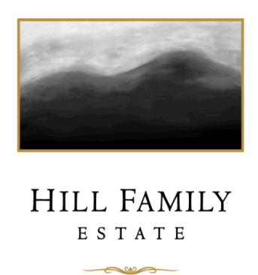

2019 “Clarke Vineyard” Syrah

Production: 398 cases
Composition: 98% Syrah and 2% Viognier
Vineyards: Clarke and Windy Flats
Cooperage: 10 months in French oak barrels, 42% new oak Canton Grand Cru American Oak barrels, 18% in 2018 Francois Freres TG M+ 3 year and Meyrieux 12% each
Alcohol: 15.6% alc, 3.75 pH, 0.6 TA
Bottling date: August 4, 2020
Release date: February 2022
Release price: $56.00

The Clarke Vineyard in American Canyon has a cool breezy climate that brings out the depth and finesse of the Syrah grape. Clone 877 is used for body and raspberry chocolate fruit, and a little Clone 383 for extra color and smoky complexity. A small amount of Viognier was co-fermented with the Syrah to add its exotic appeal. 2019 had a late veraison occur on August 9, and then the grapes settled in to achieve that nice even shrivel for gummy bear grape concentration. We brought the grapes in on October 18 at 26.8 Brix. We gave the tank three days of cold soak before adding William Selyem yeast, then pressed it on October 29. It went to barrel 2 days later and stayed in barrel for 10 months. The wine clarified on its own, so no fining or filtration was necessary at bottling. Big fruit, an interesting Mezcal note, and a soft palate characterize the Syrah from Clarke and in 2019, it again has the show stealing exotic charm that it casts every time a bottle is opened.

Winemaker Alison Doran’s tasting notes:

The 2019 Clarke Syrah offers intriguing aromas of berries, teriyaki, ginger, plum jam and wildflower honey all bouncing around. The wine glides across the tongue with flavors of black cherry, black fig, vanilla, and lychee nut.

